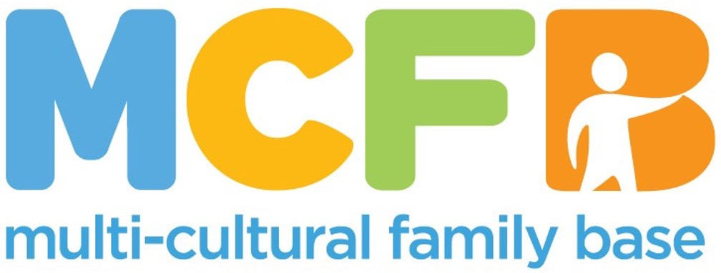

**JOB PACK**

This is a pack that gives the job description and other information about our organisation. In order to apply, please send a cover letter and CV to [hello@mcfb.org.uk](mailto:hello@mcfb.org.uk)

**ABOUT THE MULTI-CULTURAL FAMILY BASE**

The Multi-Cultural Family Base (MCFB) was established in Leith in 1998. We started because there was a recognition that there was a lack of holistic family support for ethnically diverse families in Edinburgh. Over the years we have expanded our projects in terms of age and geographical reach.

**Our Values**

Multi-Cultural Family Base is committed to promoting human rights, valuing diversity, providing equal opportunities and working in a way which is flexible, respectful, caring and empowering. Multi-Cultural Family Base is committed to involving users and stakeholders in service planning and provision.

We believe that community-based services for diverse families should be easy to access and able to respond to a wide range of needs. Our services include therapeutic groupwork and one-to-one casework. For more information go to: [www.mcfb.org.uk](http://www.mcfb.org.uk)

**ABOUT THE ROLE**

**Post: Sessional ESOL Communications Teacher**

**Hours:**  Flexible

**Pay:** SCP 19 – 23 (Based on experience and qualifications, subject to negotiation)

**Base:** 50 Coburg Street, Edinburgh, EH6 6HE, in the community as needed

**Reports to:** Pathways to Success Project Leader

**EMPLOYEE PACKAGE & BENEFITS**

✓ Flexible Working & Family Friendly – We offer flexible working hours to accommodate families, childcare and caring responsibilities.

Training opportunities on the job.

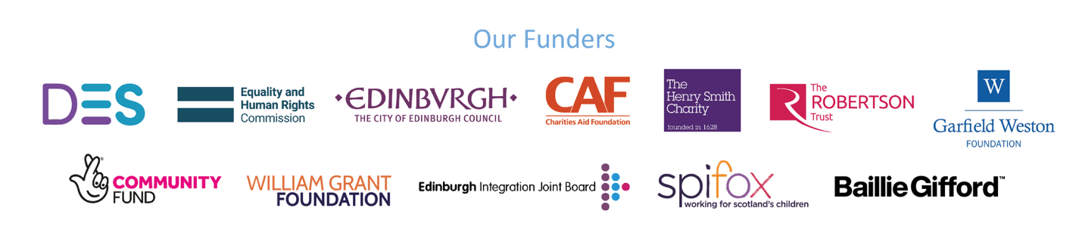

**JOB PURPOSE**

MCFB is seeking a dedicated and culturally competent ESOL Teacher to support our Pathways to Success employability programme for refugee and migrant families. This initiative is part of a wider strategy to improve life chances, build confidence, and remove barriers to employment and community engagement.

The ESOL Teacher will lead a basic-level English class with a practical focus on communication for work, daily life, and participation in community activities. There may be an opportunity to work towards formal certification for learners in future phases of the programme.

The teaching schedule will consist of 90 minutes of direct instruction each week, spanning a period of six weeks. This will involve engaging students in various educational activities, discussions, and hands-on learning experiences tailored to the curriculum.

In addition to the teaching hours, there will be an allocated 2 hours each week dedicated to preparation and evaluation. This preparation time will be used to develop lesson plans, create instructional materials, and set up any necessary resources or technology.

The evaluation time will be focused on assessing student progress, reviewing their assignments, and providing constructive feedback. This combination of teaching and preparation will ensure that students receive a comprehensive learning experience while also enabling the educator to refine and improve their instructional methods throughout the course.

**KEY RESPONSIBILITIES**

**Service Provision**

* Plan and deliver engaging, learner-centred ESOL sessions each Saturday
* Tailor teaching materials to accommodate different levels of English proficiency
* Embed employability and life-skills content into lessons
* Monitor learners’ progress and provide informal feedback
* Work alongside project staff to ensure inclusive, trauma-informed practice
* Maintain appropriate records in line with GDPR and safeguarding requirements

**Skills and specifications/Qualifications**

* Drive, energy, and commitment to helping people move towards future success in ESOL learning
* Experience working with young adults, preferably in a multicultural setting.
* Strong interpersonal and communication skills.
* Ability to plan and deliver engaging and inclusive activities related to the topic of employability.
* Understanding of cultural sensitivity and diversity.
* Valid PVG Check (or willingness to obtain).

**Communication**

* To build links with statutory and voluntary agencies providing services
* To build links with other agencies providing services to ethnically diverse communities
* To maintain accurate and up-to-date records
* To report on the progress of the project for funders and others

**Evaluation**

* To undertake assessments of young adults’ well-being and skills level at the beginning and end of each group in order to measure the impact of the provision
* To work with senior staff in developing and using evaluation tools to measure the achievement of outcomes

All employees at MCFB are expected to carry out any other duties that support our service users’ wellbeing or are necessary to support the effective running of the nonprofit.

**PERSON SPECIFICATION**

|  |  |  |  |
| --- | --- | --- | --- |
| **Criteria** | **Essential** | **Desirable** | **Assessment Method** |
| Education and Qualifications | -Direct experience of working with ethnically diverse Adults  - ESOL qualification (e.g. CELTA, TESOL, TEFL) Working Towards | - Educated to Degree Level  -CPD/ Professional Development Training undertaken in related topics (Employability, Language Provision, Child Protection, Working with Vulnerable Adults, Supporting People)  -Experience of assessing need  -Willingness to attend training sessions to upskill or keep abreast of training and research | -Application form  -Interview |
| Experience and Knowledge | - Experience working with migrant or refugee communities  - Culturally responsive, trauma-informed approach  -Knowledge of the factors that contribute to exclusion of ethnically diverse adults in society  -Knowledge of Anti-discriminatory Practice approaches and theory  -Knowledge of the factors that impact resilience | - Knowledge of adult learning principles  -Knowledge of the work of MCFB  -Commitment to the above  - Ability to embed employability-focused content  -Therapeutic Groupwork knowledge/experience  -Knowledge of Trauma based approaches to working | -Application Form  -Interview  -Reference |
| Skills and Abilities | -Skills in building trusting relationships with service users  -Excellent communication, interpersonal, and organisational skills.  -Strong attention to detail  -Professional presentation and personality  -Ability to evaluate outcomes. | -Ability to present publicly to diverse audiences  -Community language skills | -Interview  -References |
| Personal Qualities and Attitudes | -Ability to Communicate with young adults  -Ability to Communicate with Professional Colleagues  -Ability to communicate electronically and by telephone  -Ability to lead discussions and report to project leader and wider team | -Ability to compile data for reports to funders and referrers.  -Ability to record and evaluate group experiences | -Application  -Interview  -References |

An updated PVG is required for this role. We will support the transition of the PVG to MCFB.