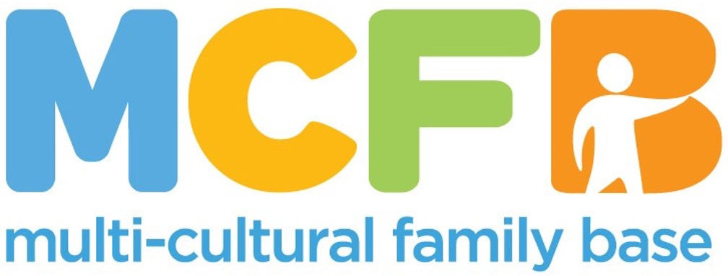

**JOB PACK**

This is a pack that gives the job description and other information about our organisation. In order to apply, please send a cover letter and CV to [hello@mcfb.org.uk](mailto:hello@mcfb.org.uk)

**ABOUT THE MULTI-CULTURAL FAMILY BASE**

The Multi-Cultural Family Base (MCFB) was established in Leith in 1998. We started because there was a recognition that there was a lack of holistic family support for ethnically diverse families in Edinburgh. Over the years we have expanded our projects in terms of age and geographical reach.

**Our Values**

Multi-Cultural Family Base is committed to promoting human rights, valuing diversity, providing equal opportunities and working in a way which is flexible, respectful, caring and empowering. Multi-Cultural Family Base is committed to involving users and stakeholders in service planning and provision.

We believe that community-based services for diverse families should be easy to access and able to respond to a wide range of needs. Our services include therapeutic groupwork and one-to-one casework. For more information go to: [www.mcfb.org.uk](http://www.mcfb.org.uk)

**ABOUT THE ROLE**

**Post Title:** Employability Assistant

**Hours:**  Flexible

**Pay:** SCP 19 – 23 (Based on experience and qualifications, subject to negotiation)

**Base:** 50 Coburg Street, Edinburgh, EH6 6HE, in the community as needed

**Reports to:** Pathways to Success Project Leader

**EMPLOYEE PACKAGE & BENEFITS**

✓ Flexible Working & Family Friendly – We offer flexible working hours to accommodate families, childcare and caring responsibilities.

Additional training is provided.

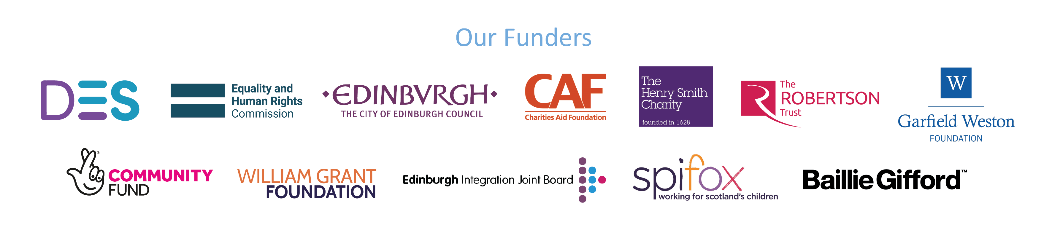

**JOB PURPOSE**

We are seeking an enthusiastic and compassionate employability assistant to support our Pathways to Success Programme. Your role as an employability assistant will be to actively identify and engage individuals with aged 16 and up who are interested in determining their future path. You will deliver access to long term, flexible, multi staged support and help remove barriers through the creation of a bespoke, personalised package based on individual need.

Our vision is that everyone is able to find their own version of their life pathway, whether it is employability, training, education, volunteering, or something else altogether. We believe that success is measured by each individuals’ skills and aspirations and hope to work together with them to figure out what those are.

**KEY RESPONSIBILITIES**

**Service Provision**

* To establish links with a network of supporting partners in order to set up and run community based empoyability provision
* To work with groups of people identified by MCFB as needing additional support in relation to their life and paths
* To plan, facilitate and evaluate engaging group work programmes for and Pathways to Success service users
* To maintain accurate and detailed records of group work sessions, including attendance, activities, and progress.
* To offer support and guidance to students who will be assisting in the work
* To assess any further needs of the people involved and to offer additional support directly or by referral to other agencies
* To adhere to organisational policies and procedures, including safeguarding and health and safety protocols.

**Skills and specifications/Qualifications**

* Drive, energy, and commitment to helping people move towards future success, whether in employment, training, education, volunteering, or other
* Experience working with young adults, preferably in a multicultural setting.
* Strong interpersonal and communication skills.
* Ability to plan and deliver engaging and inclusive activities related to the topic of employability.
* Understanding of cultural sensitivity and diversity.
* Relevant qualifications in employability are desirable.
* Valid PVG Check (or willingness to obtain).

**Communication**

* To work in partnership with community-based agencies to assist their inclusion of ethnically diverse young adults
* To have an education and development role with partner agencies in order to assist them to be more inclusive in their employability practices
* To maintain communication with the families of the people and to promote their involvement in the project and provide follow up support to maintain engagement in local services.
* To build links with statutory and voluntary agencies providing services to young people
* To build links with other agencies providing services to ethnically diverse communities
* To maintain accurate and up-to-date records
* To report on the progress of the project for funders and others

**Evaluation**

* To undertake assessments of young adults’ well-being and skills level at the beginning and end of each group in order to measure the impact of the provision
* To work with senior staff in developing and using evaluation tools to measure the achievement of outcomes

All employees at MCFB are expected to carry out any other duties that support our service users’ wellbeing or are necessary to support the effective running of the nonprofit.

**PERSON SPECIFICATION**

|  |  |  |  |
| --- | --- | --- | --- |
| **Criteria** | **Essential** | **Desirable** | **Assessment Method** |
| Education and Qualifications | -Direct experience of working with ethnically diverse Adults | - Educated to Degree Level  -CPD/ Professional Development Training undertaken in related topics (Employability, Language Provision, Child Protection, Working with Vulnerable Adults, Supporting People)  -Experience of assessing need  -Willingness to attend training sessions to upskill or keep abreast of training and research | -Application form  -Interview |
| Experience and Knowledge | -Ability to manage your own workload and prioritise as needed  -Experience of Working with ethnically diverse adults  -Knowledge of the factors that contribute to exclusion of ethnically diverse adults in society  -Knowledge of Anti-discriminatory Practice approaches and theory  -Knowledge of the factors that impact resilience | - Knowledge of the work of MCFB  -Commitment to the above  -Therapeutic Groupwork knowledge/experience  -Knowledge of Trauma based approaches to working with children. | -Application Form  -Interview  -Reference |
| Skills and Abilities | -Skills in building trusting relationships with service users  -Excellent communication, interpersonal, and organisational skills.  -Strong attention to detail  -Professional presentation and personality  -Ability to evaluate outcomes.  -IT Literacy in a range of software | -Ability to present publicly to diverse audiences  -Ability to speak a community language | -Interview  -References |
| Personal Qualities and Attitudes | -Ability to Communicate with young adults  -Ability to Communicate with Professional Colleagues  -Ability to communicate electronically and by telephone  -Ability to lead discussions and report to project leader and wider team | -Ability to compile data for reports to funders and referrers.  -Ability to record and evaluate group experiences | -Application  -Interview  -References |

An updated PVG is required for the role. We will support the transition of the PVG to MCFB.