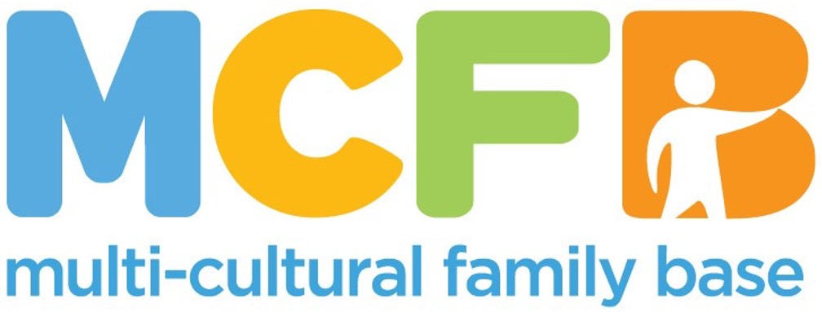

**JOB PACK**

This pack offers information on the role description and on our organisation. To apply, please complete the attached Application Pack.

**ABOUT THE MULTI-CULTURAL FAMILY BASE**

Founded with a commitment to social justice and inclusion in 1998, the Multi-Cultural Family Base (MCFB) is a leading organisation in Edinburgh dedicated to supporting diverse communities and enhancing the well-being of infants, children and families from all cultural backgrounds. MCFB provides essential community-based services, such as therapeutic group work, direct work, advocacy, and support to minoritised groups. MCFB is also a learning centre, supporting the professional development of social work students and other social care professions, with a focus on cross-cultural work and anti-racist practice.

The Early Years Service offers targeted support antenatally, and for infants and young children up to the age of 3, together with their families. Our service promotes early infant-parent relationship and positive perinatal and infant mental health through tailored group and individual therapeutic interventions. Cultural safety and reflexivity are integral to our practice.

Our referred families include new migrants, those who are seeking asylum, refugees and survivors of human trafficking.

For more information visit: [www.mcfb.org.uk](http://www.mcfb.org.uk)

**ABOUT THE ROLE**

**Post Title:** Early Years Project Leader

**Hours:**  35 hours a week

**Pay:** £ 35,605 (SCP 33)

Funded until March 2027

**Base:** Some flexibility between office/community/working remotely.

Office located at 50 Coburg Street, Edinburgh, EH6 6HE

**Reports to:** Chief Executive Officer

**EMPLOYEE PACKAGE & BENEFITS**

✓ Flexible Working & Family Friendly – We offer flexible working hours to accommodate families, childcare and caring responsibilities.

✓ Pension – All eligible staff are auto-enrolled in our Royal London pension scheme with a minimum 1.27% contribution from you and minimum 6.73% contribution from MCFB.

✓ Annual Leave - Annual leave entitlement is ample with 30 days and 12 mandatory holidays per calendar (pro-rated for part-time positions).

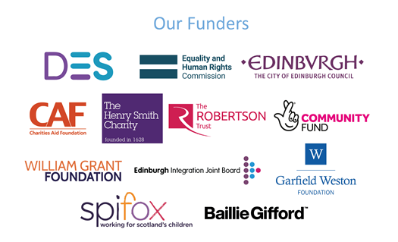

**ROLE PURPOSE**

The post holder will lead the Early Years Team, a committed small multi-disciplinary team (4 part-time Project Workers) supporting ethnically diverse families with infants and young children up to the age of 3, referred to the organisation. The service also includes a new dedicated antenatal provision.

The post holder will coordinate and develop the delivery of the project in accordance with the needs of service users, and to the expectations of funders and key stakeholders, ensuring the optimal promotion of infant mental health. The postholder will be responsible for line management of staff, students and volunteers, and contribute to direct service provision through a proportionate caseload and the delivery of groupwork.

The post holder will uphold MCFB’s mission, vision and values. They will work collaboratively across the organisation as a key member of the leadership team, ensuring effective communication and team working.

**KEY RESPONSIBILITIES**

**Project leadership for Early Years Service**

* To keep a strategic oversight of the service, identifying gaps and developing the service in accordance with identified needs.
* To have overall responsibility for project planning, monitoring and evaluation, including grant applications and progress reports.
* To have overall responsibility for assuring quality of service in line with outcomes and targets.
* To have overall responsibility for the allocated project budget.
* Recognise, manage and respond appropriately to safeguarding concerns.
* To represent the project and the agency with service users, colleagues, other agencies, stakeholders and the wider public. This includes amplifying the voices of service users and raising awareness on systemic discrimination and the disparities impacting their wellbeing and access to services.

**Service Provision**

* To oversee and undertake comprehensive assessment of the needs and risks of antenatal/early years families referred to the project.
* To manage a proportionate caseload within the project.
* To plan, facilitate and evaluate groupwork provision for early years families.
* To encourage the voice of minoritised service users in any decision making directly affecting the services delivered.

**Partnerships and Communication**

* To maintain communication with parents/carers, infants and young children to promote their involvement in the project.
* To build links and represent the organisation with statutory and voluntary agencies providing services to infants and young children including early learning and childcare, health services, social work services and voluntary sector agencies.
* To network and liaise with other agencies providing services to Black, Asian and minority ethnic communities.
* To identify opportunities to highlight issues affecting minorities families externally as well as share learning and insights with internal senior team on a regular basis and external stakeholders.

**Staffing and supervision responsibilities**

* To provide effective line management, support and supervision to project staff, volunteers or students engaged or aligned with the project.
* To develop and promote effective wider team working, communication and relationships across the organisation.
* To contribute to the Duty Senior rota on a weekly basis.
* To ensure that MCFB policies and procedures are followed.

**Evaluation**

* To oversee assessments of infants and children's well-being at the beginning and end of involvement in order to measure the impact of the provision.
* To develop and use a range of evaluation tools to measure the achievement of both funding and organisational outcomes in line with MCFB’s requirements and procedures.
* To report on the progress of the project to funders and others.
* To evaluate students’ learning progress and completion of placement

All employees at MCFB are expected to carry out any other duties that support our service users’ wellbeing or are necessary to support the effective running of the organisation.

**PERSON SPECIFICATION**

|  |  |  |  |
| --- | --- | --- | --- |
| **Criteria** | **Essential** | **Desirable** | **Assessment Method** |
| **Education and Qualifications** | *Relevant professional qualification e.g. Social Work/Psychology/Therapies/Health  *Registration with appropriate professional body | *Child Protection Postgraduate Certificate  *Practice Learning qualification (PLQ/PDA) | *Application form and supporting evidence |
| **Experience and Knowledge** | |  | | --- | | *Extensive experience of working with infants, children and families/carers in a range of settings, including within a context of safeguarding and multi-disciplinary networks.  *Knowledge and awareness of the impact of trauma on early attachment relationships, infant mental health and early development.  *Knowledge and understanding of interventions for parents-infants affected by trauma and adversity  *Understanding the impact of the dynamics of impaired early attachment relationships on teams and organisations.  * Experience of project management and evaluation strategies  *Experience of supervising staff volunteers or students. | | *Experience of working to support parent-infant relationships, through individual or group interventions.  *Experience of working with children and families within the perinatal, infancy and early years periods.  *Experience in observation and assessment of parent-infant relationships.  *Experience of using varied approaches to support early relationships. E.g. infant massage; Brazelton Newborn Behavioural Observations (NBO), Video Interactive Guidance (VIG)  *Knowledge and  Awareness of immigration law/policies and its intersectional impact on the wellbeing of families  *Knowledge and  awareness of racial disparities in maternity care outcomes.  *Work/volunteering  experience in a third-sector organisation | *Application Form  *Interview  *References |
| **Skills and Abilities** | *A high-level ability to communicate effectively, at both a written and oral level, complex and sensitive information to families and a range of professionals.  *Excellent ability to communicate with empathy and creativity, and develop strong relationships with families from diverse backgrounds who may have limited or no English.  *Excellent interpersonal and communication skills enabling the formation of networks with professionals and other agencies to promote effective network working.  *Skills in service development, including budget management.  * Skills in report writing and presentation for range of stakeholders.  * Ability to design and implement evaluation strategies.  *Strong understanding of psychodynamic and social work theories. | *Ability to speak a relevant community language | *Application form *Interview  *References |
| **Personal Qualities and Attitudes** | *Able to contain and work with emotional distress from service users and team members.  *Emotional resilience, self-motivation and ability to manage own wellbeing .  *Ability to motivate and inspire staff and students.  *Strong ethical commitment to the aims and values of MCFB  *Commitment to anti-racist practice  *Commitment to supporting the learning of others |  | *Application form *Interview  *References |

This post requires the post holder to have an updated PVG Scheme membership.

If the post holder is not a current PVG member then an application to Disclosure Scotland will be made and must be received before they can begin the post.

**Closing date**: 9th June at noon.

**Interview date**: 16th June

**Start date**: As soon as possible