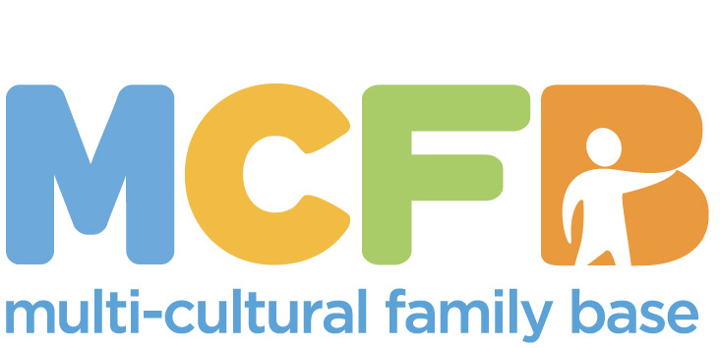

**Application form to become a Multi-Cultural Family Base Director**

**Name:**

**Address:**

**Home Phone**:

**Work Phone**:

**Mobile**:

**Email**:

**How did you hear about MCFB?**

**Why are you interested in becoming a Director for MCFB?**

**What skills and experiences do you have that may be relevant to your work as a member of the MCFB Board? This may include paid employment, voluntary work, parenting/childcare, hobbies or interests.**



**The following areas of knowledge, skills and experience are all valuable to a Trustee Board. Please indicate any areas that you consider you can bring to this role.**

* Finance
* Fundraising
* HR
* PR & Marketing
* Health and Safety
* Management
* Other specialist skills
* Children and families

# Networking

# Voluntary sector

* Diversity – eg working with minority ethnic communities or people with a disability

**What specific areas of MCFB’s work or the work of the Board interests you?**

**How much time could you offer to MCFB on a regular basis? Board meetings take place four times a year for 2-3 hours; there are also other meetings and opportunities to become involved in the work of MCFB.**

# **Is there any condition in your health, mobility or accessibility that might affect your volunteering?**

# **Image**

**REFERENCES**

**Please give us the names and addresses of two character referees (not relatives). Referees must have known you for at least two years.**

**Referee 1**

**Name:**

**Address:**

**Phone no.:**

**Capacity in which they have known you:**

**Referee 2**

**Name:**

**Address:**

**Phone no.:**

**Capacity in which they have known you:**

I understand that if I join MCFB as a Director, I will be asked to complete a criminal record check at an enhanced level. This will be giving the scheme personal details such as driving license number, passport number etc.

I consent to the use of information given in this application form for considering my application and understand that it will be treated confidentially at all times and that if I am not accepted as a Director, the information will be destroyed immediately.

I know of no reason why I would be unsuitable to become a Director.

Signed:

Date:



**Our Vision**

We believe in early intervention. This means working with children and families before problems/ issues become entrenched. We work to support children and parents dealing with important transition points - this can be the birth of a child, the move into primary school or the move to Edinburgh for families who are new migrants. We help children and families deal with issues of identity, loss, displacement and trauma. We know it is important that all children develop a sense of belonging and purpose in their lives. We work in partnership with families, listening to their views and adapting our practice to these views.

We believe passionately about issues of diversity. We work with families from a wide range of different communities, many of whom are deemed to be 'hard-to-reach'. We want to break down stereotypes and challenge prejudices. We want a society that welcomes difference and diversity, and we will advocate for families when they experience unfair discrimination.

We believe in listening carefully to children's experiences and views and we value the importance of direct work with children. We believe that play is a crucial component of children's lives and that an ability to play is a sign of positive health for children and also for adults. We value group work as a powerful tool for change and believe that groups can help children and adults find commonalities, a sense of belonging and community.

We believe in a community development approach. All of our projects have started as small pilot projects built upon a perceived or known need from working in partnership with families and other agencies. We will continue to develop new projects in response to expressed needs. We want to offer a service to families that affords time, respect, voice and understanding in often complex and difficult situations.

I fully support the vision, aims and objectives of Multi-Cultural Family Base and wish to become a member.

Name:

Address:

Postcode:

Phone: Email: 

This information will be recorded on our Membership List and only used internally. It will not be sent to other organisations or used for any marketing purposes. If you do not wish us to record your details, please tell us.

Please return this form to MCFB at the address below:

50 Coburg Street, Edinburgh EH6 6HE

T: 0131 467 7052

Email: [marybainbridge@live.co.uk](mailto:marybainbridge@live.co.uk)

Company Limited by Guarantee SC259865 Scottish Charity No. SC027644